#### 

#### Shelter Info Popup

Nielsen’s:

**Visibility of system status ✓**

The popup title is large and front-and center in the screen. The rest of the application is greyed out to clearly indicate that the focus has been shifted towards the popup. We believe that this means the user is clearly aware of where they are in the application and what’s going on.

**Match between system and the real world ✓**

We are using the system language (thus, the user will not have to read English if they don’t know it). Complicated words are not used anywhere on this screen, and icons mosty have an established meaning. The “twitter” icon is the only non-standard icon; however, twitter is a very popular service, and even regardless of its association with twitter, the checkmark is an established symbol for “yes” or “good”.

**User control and freedom ✓**

Tapping anywhere outside the popup will close the popup. If the user wants to tap something like the “family list”, which is visible behind the grey out, their first attempt will return them to the main map screen, and make it clear they’ve made progress. They can then repeat the action to do something else. Tap-outside-to-close is a common standard for Android and iOS applications. [1]

**Consistency and standards ✓**

The application maintains *internal* consistency with the shelter list by providing the information in an identical format. The “verified” checkmark maintains *external* consistency with applications like Twitter and YouTube, where verification is already standard practice. The use of *stars* maintains *external consistency* with applications such as Google Maps, Amazon and Yelp, where the star rating system is central.

**Error prevention ✘**

Most of the click boxes on the application are large. We were concerned about only making the title clickable, as the title itself is close to the edge of the screen, and it’s possible for the user to misclick and accidentally close the popup.

Fix: make the entire popup clickable, thus reducing the need for the user to tap somewhere close to the edge to receive more details about a particular shelter.

Another issue is that we originally had the review list be clickable, which would take the user straight to the reviews section of the shelter. However, we found that the star list is too small a click target, and that users tapping the shelter name may accidentally click the stars.

Fix: No longer treat the star list as a button. Users tapping on the shelter will be able to scroll down and see the reviews, and un-linking the stars gauge will prevent users from accidentally skipping past shetler info if they misclick.

**Recognition rather than recall ✓**

There is no “hidden” information the user has to remember, except for the map on which the item was selected. The map, however, is still partially visible behind the popup, giving the user a *slight* idea of where they are. We didn’t want to show a second map within the popup to avoid the user having to remember the location of the pin they clicked; this would violate the *Minimalist Design* heuristic, and might make the user interface ugly (a violation of the *Aesthetic* component of the same heuristic). We hope that the popup being quick to close and re-open is sufficient to reduce the burden on the user’s memory.

**Flexibility and efficiency of use✓**

The user can access the information in this screen in two ways: one way is by tapping the shelter list, and thereby seeing the complete list of shelters, or by tapping a single shelter and seeing information for that particular shelter. Our users can therefore use the application in ways that better suit their preferences.

**Aesthetic and minimalist design ✓**

The popup uses icons to indicate the presence or absence of resources, and includes only critical information. We believe that this interface is sufficiently minimalist, though complete.

**Help users recognize, diagnose, and recover from errors ✓**

The shelter name is given first in the popup, which means that a user who misclicked would be able to immediately see that they did so. In addition, if they select a shelter that is far away from them, they will be able to see this in the *distance* line of the popup. In this case, recovering from the error is easy: closing the popup requires only a single tab.

**Help and documentation ✓**

This screen does *not* provide any help or documentation to the user, and nor does it give any contextual help. Part of the design of this popup, though, is that it is easy to bring up and dismiss. Two of the three possible actions are telegraphed using buttons: “directions” and “meet here”. Both of these have clear meanings.

Our own:

**Offline tolerance ✓**

This popup is available for offline users who received information through peer-to-peer, bluetooth-based means. Furthermore, the “verified” checkmark is used to distinguish between official online sources and non-official “offline” sources.

**Battery efficiency ✓**

This screen doesn’t significantly contribute to battery drain, but nor does it significantly help it. We find that no action is necessary, however, because the screen is not a significant source of battery waste.

**Calm computing ✓**

This screen minimizes distractions by applying a grey overlay to the rest of the screen, and by reducing the amount of elements present in the popup itself. There is no extraneous information (c.f. adherence to the “minimal and aesthetic design” heuristic above).

**Physical Simplicity ✘**

The buttons are large and make for easy hit targets. Little precision is required when pressing the buttons or outside the popup. The most likely error is missing one of the buttons and tapping something else. Since the buttons are near the bottom of the screen, this means that missing them would close the popup.

Fix: increase the margins under the button, thus making “misclicks” hit the popup. Make this margin non-clickable, so that a user missing effectively does nothing. The fact that nothing changes should be enough to communicate to the user that they missed, letting them try again. On phones with powerful hardware, we could play the standard “ripple”[2] animation emanating from where they tapped, thus indicating that they clicked the margin and not the button itself.

“Mary’s House” and other titles are too hard to click to get extra shelter information. Users may either click past the popup, close it, or just not press anything.

Fix:make the entire shelter popup (outside the buttons) clickable. Now, the user may tap anywhere on the popup to get more information about the shelter.

**Memory and Attention ✓**

The button presents all important information to the user in a clear and straightforward way. To help focus their attention on the popup, the rest of the screen is darkened (thus making background elements not as visible). The shelter name being displayed helps make clear to the user what particular place they’re looking at.

**Attitude Towards Risk ✓**

The page has no dangerous actions that we need to warn the user about. Relying on their familiarity with other map services, we hope that the “directions” button appears nonthreatening. Furthermore, by making it blue, we’re trying to communicate to the user that there is no threat involved, and that this would be a good button to press. It seems outside of the scope of our application to explain to the user what the benefit of getting to a shelter is; interviewees in our research clearly knew of the necessity of finding a safe location.

**Communication and Collaboration** **✓**

In situations without internet connection, the various location markers for shelters are added from other people in the surrounding area. This allows for the dissemination of information, and thus satisfies this heuristics. In any situation, the stars allow for the same functionality. This is the extent to which users can communicate in the shelter / resource aspect of this application.

#### Detailed shelter information

Nielsen’s:

**Visibility of system status ✓**

**Match between system and the real world ✓**

**User control and freedom ✓**

**Consistency and standards ✓**

**Error prevention ✓**

**Recognition rather than recall ✓**

**Flexibility and efficiency of use ✓**

**Aesthetic and minimalist design ✓**

**Help users recognize, diagnose, and recover from errors ✓**

**Help and documentation ✓**

Our own:

**Offline tolerance ✓**

**Battery efficiency ✓**

**Calm computing ✓**

This page presents a lot of information, but the user must have specifically sought this information out, so we are not as stringent about requiring “extra” data.

**Physical Simplicity ✓**

**Memory and Attention ✓**

**Attitude Towards Risk ✓**

**Communication and Collaboration ✘**

Although this information can be sourced from other users, satisfying the “communication and collaboration” heuristic, what’s missing is the ability for users to share a particular shetler with their loved ones.

Fix: Add a share button to the shelter info, so that users can send the shelter’s location and data to others via chat. The image for this screens contains the newly added share button.

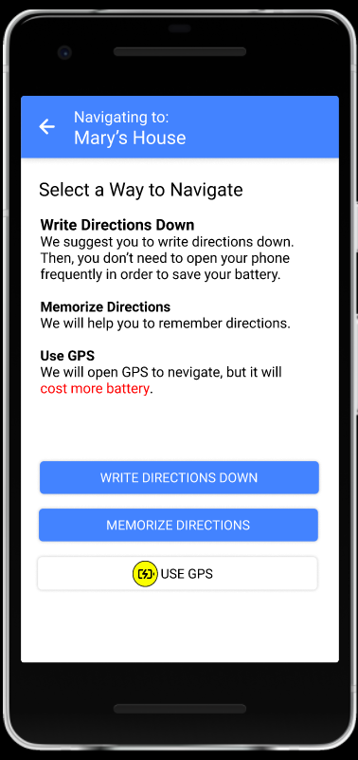

#### Navigating to Mary’s House

###### **Visibility of system status**:**✓**

Does not violate this Heuristic. The user presses the button and receives expected output.

**Match between system and the real world**:**✘**

This usability heuristic is being violated at “Use GPS”. The way the button is colored and layed out makes a user believe that they need to toggle on the feature by tapping on the button however when tapping the button it instead redirects the user to a map screen.

Fix: make the button yellow, which more clearly communicates the danger, and doesn’t look “clear” (which, as Richie noted, can be construed as a toggle instead of a button).

This button is accompanied by an icon usually associated with power saver mode when in fact this icon is supposed to inform the user that this feature consumes battery at greater pace.

Fix: update the battery icon to specifically include two “downward arrow” symbols, and therefore indicate battery drain.

###### **User control and freedom✓**

The user has the ability to undo their previous action so they are able to back out and are always in control of their system.

###### **Consistency and Standards** **✓**

Buttons follow the external standards where buttons that can be afford to be clicked on are a color other than grey. Users can expect to press the blue buttons and be redirected to the appropriate screen.

**Error Prevention✓**

The design makes it difficult for the user to cause an error. This is in line with the user control as if they make a mistake by clicking a wrong action they are able to undo their action without it causing a critical fail.

###### **Recognition vs Recall✘**

The graphical icon used for the greater battery consumption does not properly convey that information. Initial impressions appear to relate to low power mode in a lot of devices.

Fix: As noted in match between system and real world, update the icon to include downward arrows and thus more clearly communicate that it represents battery drain.

**Flexibility and Efficiency of use:**✓

The design is very simple that doesn't require unique shortcuts.

**Aesthetic and minimalist design✓**

The information presented is minimalistic and all elements convey important information and do not exist solely because it makes it look prettier.

**Help users recognize, diagnose recover from errors✓**

We didn’t use any elements that would require errors to be recognized.

**Help and Documentation✓**

There is help documentation displayed that allows the user to recognize and understand what each button does.

Our own:

**Offline tolerance ✓**

**Battery efficiency ✓**

**Calm computing ✓**

**Physical Simplicity ✓**

**Memory and Attention ✓**

**Attitude Towards Risk ✓**

The navigation button is supposed to be dangerous, but the user doesn’t know this until they click it. Then, they are greeted with a warning and a confirmation message. We want it to be clear to the user why they should be writing down or memorizing directions (what the benefits are despite the obvious risks of forgetting or getting lost).

Fix:directions screen: explain that writing down or memorizing instructions will help conserve power, and make it clear (by virtue of a yellow icon on the screen as well as a red warning text) that using GPS will drain the phone’s battery faster.

**Communication and Collaboration ✓**

#### 

#### 

#### Write Down Directions

**Visibility of system status ✘**

The navigation bar at the bottom was not clearly a navigation bar. The tester wasn’t sure that they’re *already* in the “instructions” section, and kept trying to tap on it to no effect. It needs to be made clearer that the user is *already* in the instructions tab.

Fix:underline and bold the name of the current tab, so that the user may recognize (by seeing it compared to the other tabs) that they are already in instructions. Same thing with the map tab. Also make the background grey.

The pin button does not clearly communicate that the directions have, in fact, been pinned.

Fix: Make the pin button darken in addition to switching icons from “+” to “x”.

**Match between system and the real world ✓**

**User control and freedom ✓**

**Consistency and standards ✓**

**Error prevention ✓**

**Recognition rather than recall ✘**

Although the user pressed the “write down directions” button before coming here, this screen itself does not mention writing anything down. The user must then recall what they’re doing on this screen.

Fix: change the “Directions” text at the top of the screen to “Write down these directions”, to make it more obvious that the user should be taking this information down.

**Flexibility and efficiency of use ✓**

**Aesthetic and minimalist design ✓**

**Help users recognize, diagnose, and recover from errors ✓**

**Help and documentation ✘**

It is not clear to the user what they should be doing without added context (see also the “Recognition rather than recall” heuristic above). There are no context-specific instructions to write the directions down, and there is not even a “nudge” telling the user that they can press the map button to see an alternative representation of the data.

Fix: the fix proposed in the “Recognition rather than recall” heuristic. Additionally, we might consider “pulsing” / highlighting the “Map” button in the bottom right to make it clear to the user that they can also tap that. We do not implement this for two reasons: 1) animations in paper / picture prototypes don’t show up and 2) we don’t want to distract users from writing down directions (*Memory and Attention* heuristic / facet).

Our own:

**Offline tolerance ✓**

**Battery efficiency ✓**

**Calm computing ✓**

**Physical Simplicity ✓**

**Memory and Attention ✘**

If the list of directions gets too long, it may become hard for our users (especially if they are in shock / experiencing some sort of issues with their attention or memory) to keep track of where they are in the list, even if they have a paper / pencil and they are writing it down/

Fix: we can add a small convenience feature, in which tapping one of the directions in the list underlines and bolds it, as well as places an arrow pointing to it. A user may then write down a step, return to see the step still highlighted, and then tap the next step, and move on to writing *that* down.

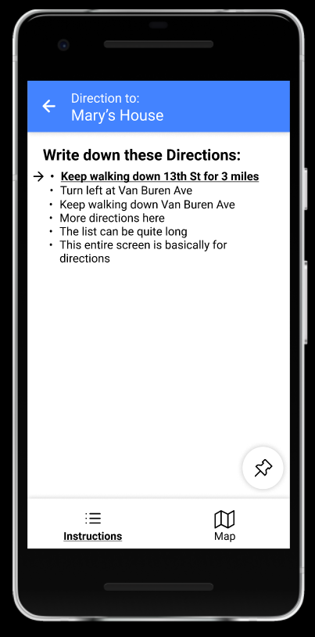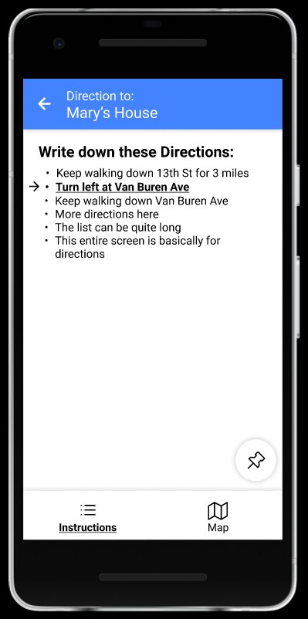

#### **Attitude Towards Risk ✓**

**Communication and Collaboration ✘**

There’s no way for users to share these directions with other users. When multiple users are near each other, sharing the same directions could be helpful in case that one of the phones dies, or if the group gets separated. We know from our interviews that users can travel in groups, so this kind of communication is plausible. Since we have a chat function for sending location information, it would also be good to share the location itself with others.

Fix: add a “share” button to directions, which gives users the option to send locations to other devices, and the location to their family circle.

#### Memorize Directions Screen

Nielsen’s:

**Visibility of system status ✓**

**Match between system and the real world ✓**

**User control and freedom ✓**

**Consistency and standards ✓**

**Error prevention ✓**

**Recognition rather than recall ✘**

This screen does not mention memorizing directions or give any instructions on how to memorize directions. As a result, the user still has to remember what this screen is about and what they're doing on this screen.

**Flexibility and efficiency of use ✓**

**Aesthetic and minimalist design ✓**

**Help users recognize, diagnose, and recover from errors ✓**

**Help and documentation ✘**

The lack of documentation in the application makes it difficult for the user to understand what they should be doing or how to do it. It would be more user-friendly if the application can give context-specific guidance on how to memorize directions.

Our own:

**Offline tolerance ✓**

**Battery efficiency ✓**

**Calm computing ✓**

**Physical Simplicity ✓**

**Memory and Attention ✓**

**Attitude Towards Risk ✓**

**Communication and Collaboration✘**

There’s no way for users to share these directions with other users. When multiple users are near each other, sharing the same directions could be helpful in case that one of the phones dies, or if the group gets separated. We know from our interviews that users can travel in groups, so this kind of communication is plausible. Since we have a chat function for sending location information, it would also be good to share the location itself with others.

Fix: add a “share” button to directions, which gives users the option to send locations to other devices, and the location to their family circle.

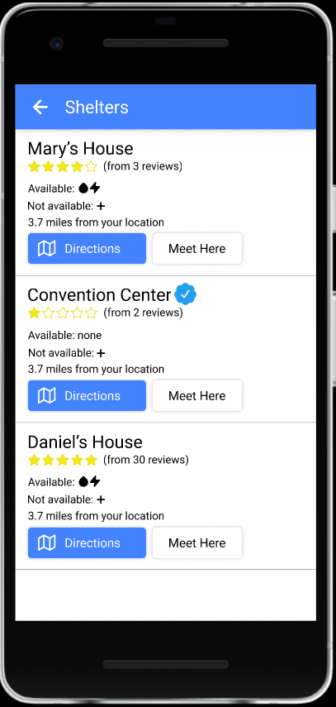

Shelter List

Nielsen’s:

**Visibility of system status ✓**

**Match between system and the real world✓**

**User control and freedom✓**

**Consistency and standards✓**

The family member list has a banner telling users when the information was last updated, whereas this screen does not. This may be an issue.

**Error prevention ✘**

Most of the click boxes on the application are large. We were concerned about only making the title clickable, as the title itself is close to the edge of the list item, and it’s possible for the user to misclick and accidentally click a different shelter.

Fix: make the entire list item clickable, thus reducing the need for the user to tap somewhere close to the edge of it to receive more details about a particular shelter.

Another issue is that we originally had the review list be clickable, which would take the user straight to the reviews section of the shelter. However, we found that the star list is too small a click target, and that users tapping the shelter name may accidentally click the stars.

Fix: No longer treat the star list as a button. Users tapping on the shelter will be able to scroll down and see the reviews, and un-linking the stars gauge will prevent users from accidentally skipping past shetler info if they misclick.

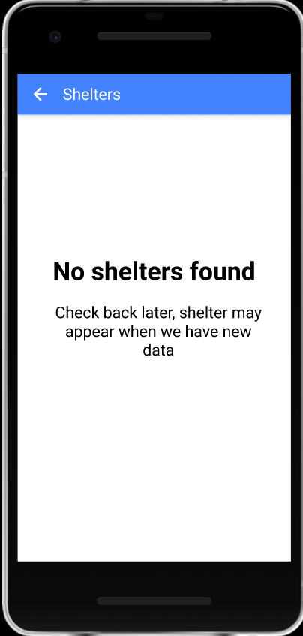

**Recognition rather than recall✓**

**Flexibility and efficiency of use✓**

**Aesthetic and minimalist design✓**

**Help users recognize, diagnose, and recover from errors✘**

If there are no known shelters nearby (which is possible given that we may simply not have any available data), we don’t have any special screen for our user. As things stand at the time of evaluation, they may be presented with an empty screen. This does not clearly communicate what’s going on, and nor does it tell our users what to do.

Fix:add a special message if no shelters are known.

Potential Fix: Another possible solution is to help them *create* or *secure* shelter (explain how to waterproof an area, build a tent, distill water, or other things that would help them create a safe area if escape is not possible). This would go nicely with people who are stranded, like one of our Katrina interview transcripts (stranded in hospital for a week)

**Help and documentation✓**

Our own:

**Offline tolerance✓**

**Battery efficiency✓**

There isn’t any message to remind users to save power. Users may spend a long time here and power will drop. However, we trust that users will not be as pressured by intermittent reinforcement in the *shelter* list (the reward for a new shelter showing up is miles away from the reward for an update on a loved one).

**Calm computing✓**

**Physical Simplicity✓**

**Memory and Attention✓**

**Attitude Towards Risk✓**

**Communication and Collaboration✘**

There isn’t any for users to share their shelter list with others. It would be helpful if a user can share his shelter list with other users and help them to locate the shelter.

Fix: add a “share” button, which gives users the option to share the shelter list they have to the other users.

GPS Navigation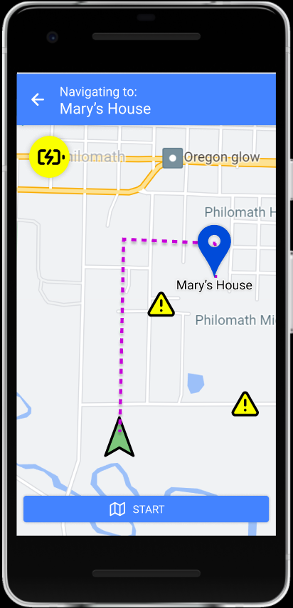

Nielsen’s:

**Visibility of system status ✓**

**Match between system and the real world ✓**

**User control and freedom ✓**

**Consistency and standards ✓**

**Error prevention ✓**

**Recognition rather than recall ✓**

**Flexibility and efficiency of use ✓**

**Aesthetic and minimalist design ✓**

**Help users recognize, diagnose, and recover from errors ✓**

**Help and documentation ✓**

Our own:

**Offline tolerance ✓**

**Battery efficiency ✓**

Since the user chooses to use GPS, the power efficiency will not apply. We will not change this because the user wants to. And we will notify the user that they are consuming more power by the battery icon.

**Calm computing ✓**

**Physical Simplicity ✓**

**Memory and Attention ✓**

**Attitude Towards Risk ✓**

**Communication and Collaboration✓**

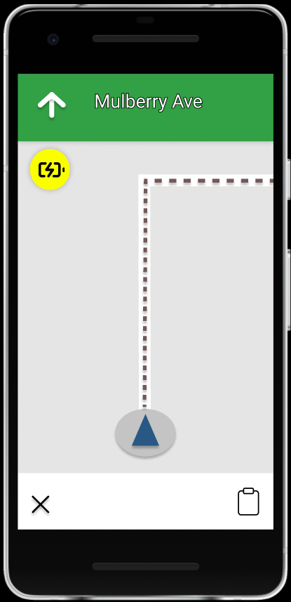

GPS Navigation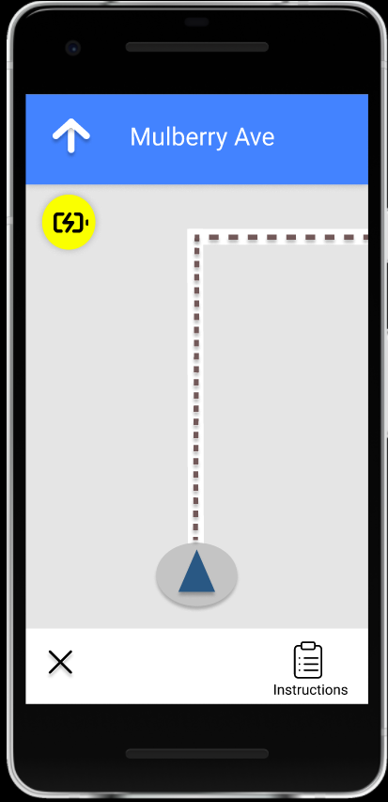

Nielsen’s:

**Visibility of system status ✓**

**Match between system and the real world ✓**

**User control and freedom ✓**

**Consistency and standards ✓**

**Error prevention ✓**

There is no exit confirmation when the user clicks the exit button. We do not intend to fix this, since we want to keep the navigation system the same as Google Maps, so the user will feel more comfortable with navigation.

**Recognition rather than recall ✓**

**Flexibility and efficiency of use ✓**

**Aesthetic and minimalist design ✓**

**Help users recognize, diagnose, and recover from errors ✓**

**Help and documentation ✓**

Our own:

**Offline tolerance ✓**

**Battery efficiency ✓**

Since the user chooses to use GPS, the power efficiency will not apply. We will not change this because the user wants to. And we will notify the user that they are consuming more power by the battery icon.

**Calm computing ✓**

**Physical Simplicity ✓**

**Memory and Attention ✓**

**Attitude Towards Risk ✓**

**Communication and Collaboration ✓**

1. See for instance the modal dialog example on the Material Design page: <https://material.io/components/dialogs#usage>
2. <https://material.io/develop/ios/supporting/ripple>